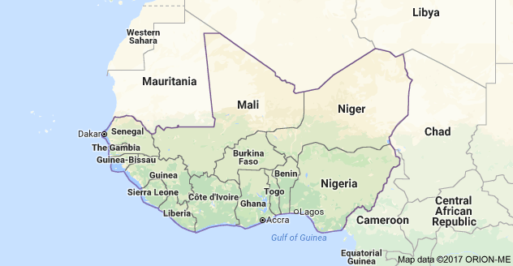**WAWA (SIERRA LEONE) Visitors’ Welcome Pack**

|  |  |
| --- | --- |
| **Scope** | **Regional People Management Framework** |
| **Introduction** | The nature of WaterAid’s work necessitates working in volatile and sometimes violent environments. At times this presents a threat to the security and well-being of our staff; an issue the organisation takes very seriously.  A Country Welcome Pack provides staff and visitors with a broad overview of the environment in which they are working or travelling to including essential security information good to know prior to visiting. It describes other factors that may not be included in a security plan such as currency information, cultural norms, local considerations, sensitivities, etc. |
| **Purpose** | The aim of this document is to inform short-term visitors of useful information that is important for their visit. Your welcome pack should:   * Provide a brief summary of the country including safety and security * Provide information on cultural practices * Provide information regarding airports and accommodation * Provide useful hints and tips regarding dress, communications, electricity, currency, eating out, getting around, health and climate. * Contain a short declaration to be signed by the visitor after the In-Country security briefing, whereby acknowledging that s/he is informed and understand the risks (informed consent). * To satisfy one of the requirements of WA’s duty of care.   Preferably visitors should be able to access this – or receive by mail – prior to departing for your country as a Pre-Departure brief. |
| **First Published** | **2017** |
| **First Revision** |  |

**CHAPTER 1: Global Security Framework**

**1.1 Global Security Framework**

* + 1. This document is part of the Global Security Framework that consists of policies, a toolkit, procedures and a template pack, as illustrated below.

Policies

Toolkit

Procedures

Templates

Global Security Policy

Emergency Number

Crisis Management

Medical Response & Evacuation

Repatriation of Deceased

Psychosocial Care

Incident Reporting

Kidnap

Security Handbook

Essential Security Package

Security Plan

Welcome Pack

‘RED’ Form

Contingency Plans

Risk Assessment

Context Analysis

Incident Report Form

International & Domestic Travel

* + 1. Pictures of important sites and monuments within the country.

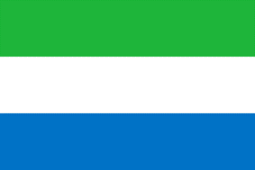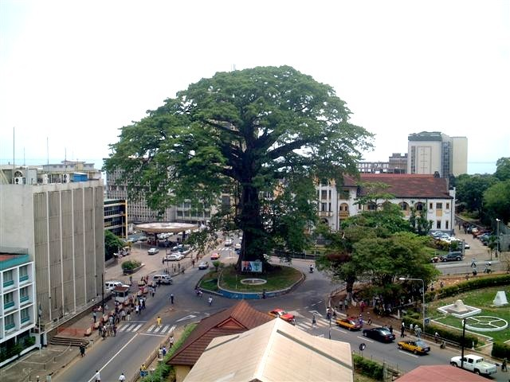

[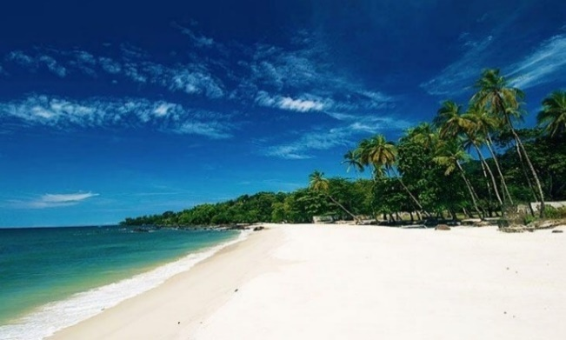](https://www.google.com.sl/url?sa=i&rct=j&q=&esrc=s&source=images&cd=&cad=rja&uact=8&ved=0ahUKEwjstJ2liZ_NAhVBnBoKHS-OCU4QjRwIBw&url=https://www.pinterest.com/pin/247557310739613327/&bvm=bv.124272578,d.d2s&psig=AFQjCNEpHCq4P1nkTqSbYuwzTOmxMhqomA&ust=1465703507972385)

**CHAPTER 2: INTRODUCTION**

2.1.1 WaterAid Sierra Leone is often hosting international visitors from member offices, donors and supporters.

The aim of this Welcome Pack is to inform short-term visitors of useful information that is important for their visit. It is updated regularly to reflect current security situation in the country, and will also provide some useful information that visitors should know before starting their journey.

The document serves as a Pre-Departure Brief and will be supplemented by a verbal security briefing upon arrival in Freetown.

**CHAPTER 3: SECURITY WELCOME PACK**

**3.1 Country Summary**

Sierra Leone is located on the West Coast of Africa between latitudes 70 and 100 north of the equator. The country shares border with the Republic of Guinea on the North to the Northeast, on the south to the Southeast by the Republic of Liberia and by the Atlantic Ocean to the west. Sierra Leone has a total area of 27, 699 square miles or 71; 740km2 of which 120km2 is water and 71, 620km2 is land where only 18% is arable.

Sierra Leone has a population of 7,075,641 persons and sixteen (16) ethnic groups of which the Temne and the Mende tribes form 35% and 31% respectively.

The Sierra Leone People’s Party (SLPP) is the ruling party and Rtd. Brdg. Dr. Julius Maada Bio is President of the republic of Sierra Leone. The former opposition flag bearer won the peoples mandate from the general elections that was held early this year.

**Political system: Republic, multiparty system**

**WaterAid Operation**

WaterAid Sierra Leone implements its programme at national and local levels. WA SL implements our WASH Governance at national level while we implement WASH Service delivery and Integrated WASH in three districts out of 16 political districts. Two of the districts i.e. Kenema(UKAM-Untapped & Unrestricted) and Kailahun(Unrestricted) are in the Eastern province and Pujehun district is in the Southern province bordering Liberia where the Swedish funded & UKAM-Untapped projects are been implemented.

**Religions**

Christianity and Islam are the main religious sects in Sierra Leone with the latter being the dominant. Unlike other countries, Sierra Leone is highly esteemed for its religious tolerance. Shaking of hands is very common without barrier.

**Weather**

Sierra Leone has distinct wet and dry seasons. Most of the rainfall occurs from May to October and the dry season occurs from November to April marked by mild, dusty hamattan winds in December, January and February. The annual rainfall is about 2,000 to 3,000mm/annum, which is one of the highest in West Africa. The night time temperature is around 22/24 °C along the coast, and 18/20 °C in inland areas, while the daytime temperatures are around 30 °C on the coast and 32/34 °C in the interior.

**3.2 Entry Requirements**

Entering to Sierra Leone requires Visa if you are a Non-ECOWAS citizen, in addition one must have a Yellow Fever Certificate. Once you get to the airport, please produce on demand your Passport and Yellow Fever Certificate for inspection.

Upon arrival at the Airport you will be picked up by an assigned agent and will accompany you to the shuttle, safely drive to the speedboat terminal crossing point where you will on-board the Pelican speedboat for 25 minutes to ferry you to Aberdeen bridge in Freetown. Please you can contact this number at the airport +232 79735330.

A WaterAid vehicle will then pick you at the Aberdeen Bridge in Freetown and drive you to the Hotel

**3.3 Safety & Security**

Freetown, the capital city is quiet but with minimal criminal activity like pick pockets. However, for your safety, you are advised to keep your jewels and handbags tight when out of a secured environment especially market areas. You may use the hotel safe to keep your valuables. Ensure when going out to town/crowded area/ the beach area you handle your cash well for pick - pockets not to take away. Political situation is getting charged due to the forth coming presidential and general elections; however, there are isolated cases of political intolerance leading to violence this will not affect you.

Malaria is prevalent in Sierra Leone and is a serious health risk. To avoid being infected, kindly follow all the known preventive measures required. In case you feel symptoms of malaria or any other disease, kindly contact a member of staff (preferably the Country Director) who will support you acquire the needed medical attention.

We advise you to take your International Travel Vaccination against Yellow Fever. Please ensure you update your travel medical insurance and WHO’s International Certificate of Vaccination – Yellow Card. Upon arrival, you will be provided with verbal security briefing from the security focal point.

**3.4 Nice to Know**

A WaterAid staff will support you carry out any financial transaction during your stay in Sierra Leone. The current exchange rate of the local currency-the Leone to other currency is as follows:

£1.00 = Le10,000

$1.00 =Le8, 250

€1.00 =Le 9, 300

However, these exchanges rates fluctuate very often. *Credit Cards are not widely accepted but ATMs are common at some banks. Availability of strong Internet connectivity is a challenge but it is available at the hotel and WaterAid office.*

*Current rating here is 240V – please consider these type of plugs when coming.*

*If you want to move around without WaterAid vehicle and staff, please only hire hotel cars for safety and security.*

*In Sierra Leone, tips is not a crime nor an obligation on the side of customers at restaurants, gas station, supermarkets, pubs etc. and it depends on what you want to give.*

***Restaurants***

* Family Kingdom - Aberdeen, Freetown
* Radisson Blu, Mammy Yoko – Aberdeen, Freetown
* Roy - Aberdeen, Freetown
* Basha Restaurant, Wilkinson Road, Freetown

*The Official language here is English. For local, krio is widely spoken. When it comes to Sightseeing, for some areas you will pay. Like natural reserves where wild animal are kept and for photographing/filming once you are issued permit you can do your photographing/filming anywhere.*

**3.5 Key Contacts**

Country code is +232.

a: WA [Sierra Leone]:

Landline: +23225259081/+23225244739

Mobile:

b: Country Director: Patrick Cheah

Mobile: +232(0)79401040 /+232(0)77401040

c: SFP: (Patrick Musa )

Mobile: +232(0)76607725/+232(0)99391242